

**МИНОБРНАУКИ РОССИИ**

**федеральное государственное бюджетное образовательное учреждение**

**высшего образования**

**«Московский государственный технологический университет «СТАНКИН»**

**(ФГБОУ ВО «МГТУ «СТАНКИН»)**

|  |  |
| --- | --- |
| **Институт**  **информационных**  **систем и технологий** | **Кафедра информационных систем** |

**Основная образовательная программа 09.03.02  
«Информационные системы и технологии»**

**дисциплина «Технологии разработки программных средств»**

**Отчет по**

**Лабораторной работе №3**

**«Разработка пользовательского интерфейса программного средства»**

|  |  |
| --- | --- |
| Студент  группы ИДБ-19-06 | Макаров М.А. |
|  |  |
| Преподаватель  к.т.н., доц. | Волкова О. Р. |

**Цель**: формирование навыков создания графического пользовательского интерфейса.

**1.Макет программы**

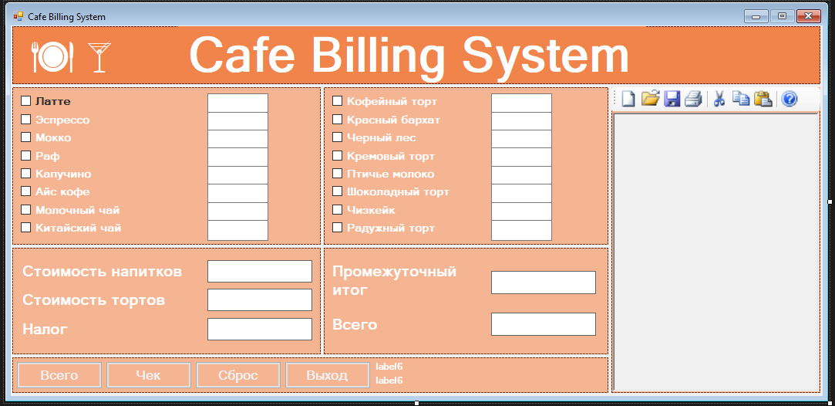

**2.Навигационная модель пользовательского интерфейса**

1. **Варианты ввода данных**

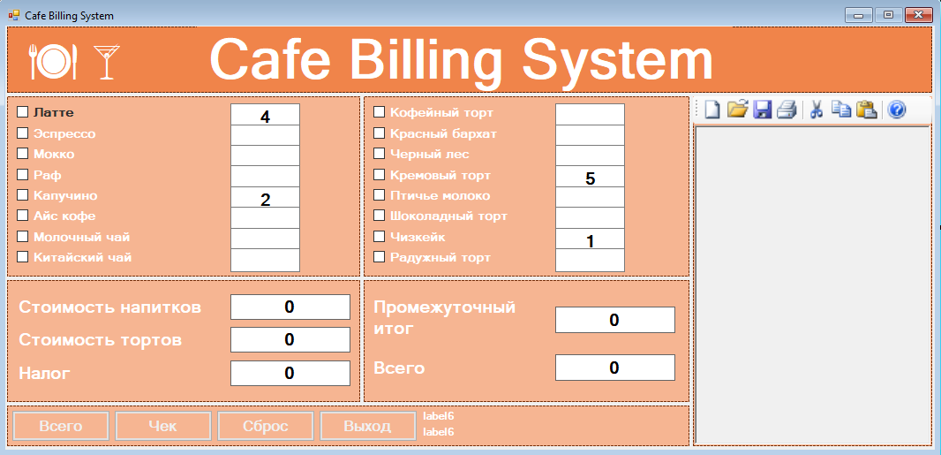

1. **Сохранение чека в формате .txt**

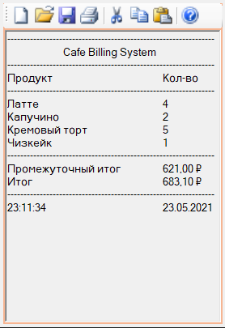

**3.Реализация разработанного макета пользовательского интерфейса**

using System;

using System.Collections.Generic;

using System.ComponentModel;

using System.Data;

using System.Drawing;

using System.Linq;

using System.Text;

using System.Threading.Tasks;

using System.Windows.Forms;

using System.Globalization;

namespace CafeManagement

{

public partial class Form1 : Form

{

public Form1()

{

InitializeComponent();

//test

}

private void button3_Click(object sender, EventArgs e)

{ //btnReset

txtLatte.Text = "0";

txtEspresso.Text = "0";

txtMocha.Text = "0";

txtRafCoffee.Text = "0";

txtCappu.Text = "0";

txtAfricanCoffee.Text = "0";

txtMilkTea.Text = "0";

txtChineseTea.Text = "0";

txtCoffeCake.Text = "0";

txtRedValvetCake.Text = "0";

txtBlackForestCake.Text = "0";

txtBostonCream.Text = "0";

txtSouffleCake.Text = "0";

txtKillburnChoco.Text = "0";

txtCheeseCake.Text = "0";

txtRainbowCake.Text = "0";

lblCakeCost.Text = "0";

lblDrinkCost.Text = "0";

lblCakeCostnotax.Text = "0";

lblDrinkCostnotax.Text = "0";

lblTax.Text = "0";

lblTotalNoTax.Text = "0";

lblTotal.Text = "0";

chkLatte.Checked = false;

chkEspresso.Checked = false;

chkMocha.Checked = false;

chkRafCoffee.Checked = false;

chkCappucino.Checked = false;

chkAfricanCoffe.Checked = false;

chkMilkTea.Checked = false;

chkChineseTea.Checked = false;

chkRedValvet.Checked = false;

chkCoffe.Checked = false;

chkBlackForest.Checked = false;

chkBostonCream.Checked = false;

chkSouffle.Checked = false;

chkKilburnChoco.Checked = false;

chkCheese.Checked = false;

chkRainbowCake.Checked = false;

}

private void button2_Click(object sender, EventArgs e)

{

//btnReceipt

rtfReceipt.Clear();

// rtfReceipt.AppendText(Environment.NewLine);

rtfReceipt.AppendText("\t\t" + "Кассовый чек" + Environment.NewLine);

rtfReceipt.AppendText(Environment.NewLine + "ПРИХОД" + "\t\t\t" + Environment.NewLine);

rtfReceipt.AppendText("----------------------------------------------------------------" + Environment.NewLine);

rtfReceipt.AppendText("\t\t" + " Starbucks" + Environment.NewLine);

rtfReceipt.AppendText("----------------------------------------------------------------" + Environment.NewLine);

rtfReceipt.AppendText("Продукт" + "\t\t\t" + "Кол-во" + Environment.NewLine);

rtfReceipt.AppendText("----------------------------------------------------------------" + Environment.NewLine);

if (chkLatte.Checked == true)

{

rtfReceipt.AppendText("Латте \t\t\t\t" + txtLatte.Text + Environment.NewLine);

// rtfReceipt.AppendText("В т.ч. НДС 10% \t\t\t" + Environment.NewLine);

}

else

{

}

if (chkEspresso.Checked == true)

{

rtfReceipt.AppendText("Эспрессо \t\t\t" + txtEspresso.Text + Environment.NewLine);

}

else

{

}

if (chkMocha.Checked == true)

{

rtfReceipt.AppendText("Мокко \t\t\t\t" + txtMocha.Text + Environment.NewLine);

}

else

{

}

if (chkRafCoffee.Checked == true)

{

rtfReceipt.AppendText("Раф \t\t\t\t" + txtRafCoffee.Text + Environment.NewLine);

}

else

{

}

if (chkCappucino.Checked == true)

{

rtfReceipt.AppendText("Капучино \t\t\t" + txtCappu.Text + Environment.NewLine);

}

else

{

}

if (chkAfricanCoffe.Checked == true)

{

rtfReceipt.AppendText("Айс кофе \t\t\t" + txtAfricanCoffee.Text + Environment.NewLine);

}

else

{

}

if (chkMilkTea.Checked == true)

{

rtfReceipt.AppendText("Молочный чай \t\t" + txtMilkTea.Text + Environment.NewLine);

}

else

{

}

if (chkChineseTea.Checked == true)

{

rtfReceipt.AppendText("Китайский чай \t\t" + txtChineseTea.Text + Environment.NewLine);

}

else

{

}

if (chkCoffe.Checked == true)

{

rtfReceipt.AppendText("Кофейный торт \t\t" + txtCoffeCake.Text + Environment.NewLine);

}

else

{

}

if (chkRedValvet.Checked == true)

{

rtfReceipt.AppendText("Красный бархат \t\t" + txtRedValvetCake.Text + Environment.NewLine);

}

else

{

}

if (chkBlackForest.Checked == true)

{

rtfReceipt.AppendText("Черный лес \t\t\t" + txtBlackForestCake.Text + Environment.NewLine);

}

else

{

}

if (chkBostonCream.Checked == true)

{

rtfReceipt.AppendText("Кремовый торт \t\t" + txtBostonCream.Text + Environment.NewLine);

}

else

{

}

if (chkSouffle.Checked == true)

{

rtfReceipt.AppendText("Птичье молоко \t\t" + txtSouffleCake.Text + Environment.NewLine);

}

else

{

}

if (chkKilburnChoco.Checked == true)

{

rtfReceipt.AppendText("Шоколадный торт \t\t" + txtKillburnChoco.Text + Environment.NewLine);

}

else

{

}

if (chkCheese.Checked == true)

{

rtfReceipt.AppendText("Чизкейк \t\t\t" + txtCheeseCake.Text + Environment.NewLine);

}

else

{

}

if (chkRainbowCake.Checked == true)

{

rtfReceipt.AppendText("Радужный торт \t\t" + txtRainbowCake.Text + Environment.NewLine);

}

else

{

}

rtfReceipt.AppendText("----------------------------------------------------------------" + Environment.NewLine);

//rtfReceipt.AppendText("НДС 10% \t\t\t\t"); //+ lblTax.Text + Environment.NewLine);

rtfReceipt.AppendText("Итог \t\t\t\t=" + lblTotal.Text + Environment.NewLine);

rtfReceipt.AppendText("Сумма без НДС \t\t=" + lblTotalNoTax.Text + Environment.NewLine);

rtfReceipt.AppendText("----------------------------------------------------------------" + Environment.NewLine);

rtfReceipt.AppendText(lblTimer.Text + "\t\t\t" + lblDate.Text);

}

private void btnExit_Click(object sender, EventArgs e)

{

Application.Exit();

double latteeCof = Convert.ToDouble(txtLatte.Text);

}

private void Form1_Load(object sender, EventArgs e)

{

lblDate.Text = DateTime.Now.ToShortDateString();

timer1.Start();

txtLatte.Text = "0";

txtEspresso.Text = "0";

txtMocha.Text = "0";

txtRafCoffee.Text = "0";

txtCappu.Text = "0";

txtAfricanCoffee.Text = "0";

txtMilkTea.Text = "0";

txtChineseTea.Text = "0";

txtCoffeCake.Text = "0";

txtRedValvetCake.Text = "0";

txtBlackForestCake.Text = "0";

txtBostonCream.Text = "0";

txtSouffleCake.Text = "0";

txtKillburnChoco.Text = "0";

txtCheeseCake.Text = "0";

txtRainbowCake.Text = "0";

lblCakeCost.Text = "0";

lblDrinkCost.Text = "0";

lblCakeCostnotax.Text = "0";

lblDrinkCostnotax.Text = "0";

lblTotalNoTax.Text = "0";

lblTax.Text = "0";

lblTotal.Text = "0";

txtLatte.Enabled = false;

txtEspresso.Enabled = false; ;

txtMocha.Enabled = false;

txtRafCoffee.Enabled = false;

txtCappu.Enabled = false;

txtAfricanCoffee.Enabled = false;

txtMilkTea.Enabled = false;

txtChineseTea.Enabled = false;

txtCoffeCake.Enabled = false;

txtRedValvetCake.Enabled = false;

txtBlackForestCake.Enabled = false;

txtBostonCream.Enabled = false;

txtSouffleCake.Enabled = false;

txtKillburnChoco.Enabled = false;

txtCheeseCake.Enabled = false;

txtRainbowCake.Enabled = false;

chkLatte.Checked = false;

chkEspresso.Checked = false;

chkMocha.Checked = false;

chkRafCoffee.Checked = false;

chkCappucino.Checked = false;

chkAfricanCoffe.Checked = false;

chkMilkTea.Checked = false;

chkChineseTea.Checked = false;

chkRedValvet.Checked = false;

chkCoffe.Checked = false;

chkBlackForest.Checked = false;

chkBostonCream.Checked = false;

chkSouffle.Checked = false;

chkKilburnChoco.Checked = false;

chkCheese.Checked = false;

chkRainbowCake.Checked = false;

rtfReceipt.Clear();

}

private void chkLatte_CheckedChanged(object sender, EventArgs e)

{

if (chkLatte.Checked==true)

{

txtLatte.Enabled = true;

txtLatte.Text = "1";

}

else

{

txtLatte.Enabled = false;

txtLatte.Text = "0";

}

}

private void txtLatte_Click(object sender, EventArgs e)

{

txtLatte.Text = "";

txtLatte.Focus();

}

private void chkEspresso_CheckedChanged(object sender, EventArgs e)

{

if (chkEspresso.Checked == true)

{

txtEspresso.Enabled = true;

txtEspresso.Text = "1";

}

else

{

txtEspresso.Enabled = false;

txtEspresso.Text = "0";

}

}

private void txtEspresso_Click(object sender, EventArgs e)

{

txtEspresso.Text = "";

txtEspresso.Focus();

}

private void chkMocha_CheckedChanged(object sender, EventArgs e)

{

if (chkMocha.Checked == true)

{

txtMocha.Enabled = true;

txtMocha.Text = "1";

}

else

{

txtMocha.Enabled = false;

txtMocha.Text = "0";

}

}

private void txtMocha_Click(object sender, EventArgs e)

{

txtMocha.Text = "";

txtMocha.Focus();

}

private void chkRafCoffee_CheckedChanged(object sender, EventArgs e)

{

if (chkRafCoffee.Checked == true)

{

txtRafCoffee.Enabled = true;

txtRafCoffee.Text = "1";

}

else

{

txtRafCoffee.Enabled = false;

txtRafCoffee.Text = "0";

}

}

private void txtRafCoffee_Click(object sender, EventArgs e)

{

txtRafCoffee.Text = "";

txtRafCoffee.Focus();

}

private void chkCappucino_CheckedChanged(object sender, EventArgs e)

{

if (chkCappucino.Checked == true)

{

txtCappu.Enabled = true;

txtCappu.Text = "1";

}

else

{

txtCappu.Enabled = false;

txtCappu.Text = "0";

}

}

private void txtCappu_Click(object sender, EventArgs e)

{

txtCappu.Text = "";

txtCappu.Focus();

}

private void chkAfricanCoffe_CheckedChanged(object sender, EventArgs e)

{

if (chkAfricanCoffe.Checked == true)

{

txtAfricanCoffee.Enabled = true;

txtAfricanCoffee.Text = "1";

}

else

{

txtAfricanCoffee.Enabled = false;

txtAfricanCoffee.Text = "0";

}

}

private void txtAfricanCoffee_Click(object sender, EventArgs e)

{

txtAfricanCoffee.Text = "";

txtAfricanCoffee.Focus();

}

private void chkMilkTea_CheckedChanged(object sender, EventArgs e)

{

if (chkMilkTea.Checked == true)

{

txtMilkTea.Enabled = true;

txtMilkTea.Text = "1";

}

else

{

txtMilkTea.Enabled = false;

txtMilkTea.Text = "0";

}

}

private void txtMilkTea_Click(object sender, EventArgs e)

{

txtMilkTea.Text = "";

txtMilkTea.Focus();

}

private void chkChineseTea_CheckedChanged(object sender, EventArgs e)

{

if (chkChineseTea.Checked == true)

{

txtChineseTea.Enabled = true;

txtChineseTea.Text = "1";

}

else

{

txtChineseTea.Enabled = false;

txtChineseTea.Text = "0";

}

}

private void txtChineseTea_Click(object sender, EventArgs e)

{

txtChineseTea.Text = "";

txtChineseTea.Focus();

}

private void chkCoffe_CheckedChanged(object sender, EventArgs e)

{

if (chkCoffe.Checked == true)

{

txtCoffeCake.Enabled = true;

txtCoffeCake.Text = "1";

}

else

{

txtCoffeCake.Enabled = false;

txtCoffeCake.Text = "0";

}

}

private void txtCoffeCake_Click(object sender, EventArgs e)

{

txtCoffeCake.Text = "";

txtCoffeCake.Focus();

}

private void chkRedValvet_CheckedChanged(object sender, EventArgs e)

{

if (chkRedValvet.Checked == true)

{

txtRedValvetCake.Enabled = true;

txtRedValvetCake.Text = "1";

}

else

{

txtRedValvetCake.Enabled = false;

txtRedValvetCake.Text = "0";

}

}

private void txtRedValvetCake_Click(object sender, EventArgs e)

{

txtRedValvetCake.Text = "";

txtRedValvetCake.Focus();

}

private void chkBlackForest_CheckedChanged(object sender, EventArgs e)

{

if (chkBlackForest.Checked == true)

{

txtBlackForestCake.Enabled = true;

txtBlackForestCake.Text = "1";

}

else

{

txtBlackForestCake.Enabled = false;

txtBlackForestCake.Text = "0";

}

}

private void txtBlackForestCake_Click(object sender, EventArgs e)

{

txtBlackForestCake.Text = "";

txtBlackForestCake.Focus();

}

private void chkBostonCream_CheckedChanged(object sender, EventArgs e)

{

if (chkBostonCream.Checked == true)

{

txtBostonCream.Enabled = true;

txtBostonCream.Text = "1";

}

else

{

txtBostonCream.Enabled = false;

txtBostonCream.Text = "0";

}

}

private void txtBostonCream_Click(object sender, EventArgs e)

{

txtBostonCream.Text = "";

txtBostonCream.Focus();

}

private void chkSouffle_CheckedChanged(object sender, EventArgs e)

{

if (chkSouffle.Checked == true)

{

txtSouffleCake.Enabled = true;

txtSouffleCake.Text = "1";

}

else

{

txtSouffleCake.Enabled = false;

txtSouffleCake.Text = "0";

}

}

private void txtSouffleCake_Click(object sender, EventArgs e)

{

txtSouffleCake.Text = "";

txtSouffleCake.Focus();

}

private void chkKilburnChoco_CheckedChanged(object sender, EventArgs e)

{

if (chkKilburnChoco.Checked == true)

{

txtKillburnChoco.Enabled = true;

txtKillburnChoco.Text = "1";

}

else

{

txtKillburnChoco.Enabled = false;

txtKillburnChoco.Text = "0";

}

}

private void txtKillburnChoco_Click(object sender, EventArgs e)

{

txtKillburnChoco.Text = "";

txtKillburnChoco.Focus();

}

private void chkCheese_CheckedChanged(object sender, EventArgs e)

{

if (chkCheese.Checked == true)

{

txtCheeseCake.Enabled = true;

txtCheeseCake.Text = "1";

}

else

{

txtCheeseCake.Enabled = false;

txtCheeseCake.Text = "0";

}

}

private void txtCheeseCake_Click(object sender, EventArgs e)

{

txtCheeseCake.Text = "";

txtCheeseCake.Focus();

}

private void chkRainbowCake_CheckedChanged(object sender, EventArgs e)

{

if (chkRainbowCake.Checked == true)

{

txtRainbowCake.Enabled = true;

txtRainbowCake.Text = "1";

}

else

{

txtRainbowCake.Enabled = false;

txtRainbowCake.Text = "0";

}

}

private void txtRainbowCake_Click(object sender, EventArgs e)

{

txtRainbowCake.Text = "";

txtRainbowCake.Focus();

}

private void timer1_Tick(object sender, EventArgs e)

{

lblTimer.Text = DateTime.Now.ToLongTimeString();

}

private void printDocument1_PrintPage(object sender, System.Drawing.Printing.PrintPageEventArgs e)

{

e.Graphics.DrawString(rtfReceipt.Text, new Font("Arial", 14, FontStyle.Regular), Brushes.Black, 120, 120);

}

private void printToolStripButton_Click(object sender, EventArgs e)

{

printPreviewDialog1.Document = printDocument1;

printPreviewDialog1.ShowDialog();

}

private void newToolStripButton_Click(object sender, EventArgs e)

{

rtfReceipt.Clear();

}

private void cutToolStripButton_Click(object sender, EventArgs e)

{

rtfReceipt.Cut();

}

private void copyToolStripButton_Click(object sender, EventArgs e)

{

rtfReceipt.Copy();

}

private void pasteToolStripButton_Click(object sender, EventArgs e)

{

rtfReceipt.Paste();

}

}

}

}

**4.Реализация разработанного макета пользовательского интерфейса**

**Вывод рассчитанной стоимости напитков, тортов, налога, промежуточного итога и общей стоимости**

private void button1_Click(object sender, EventArgs e)

{ //btnTotal

double lat, mocha, espr, Raf, cappu, afri, mTea, cTea;

double cCake, rValvet, bFor, bCream, souf, Choco, cheese, rain;

double tax;

tax = 10;

lat = 49; mocha = 50; espr = 80; Raf = 59; cappu = 70; afri = 85; mTea = 40; cTea = 55; //coffee pries

cCake = 50; rValvet = 100; bFor = 60; bCream = 40; souf = 79; Choco = 109; cheese = 85; rain = 89; //cake prices

CultureInfo culture = CultureInfo.CreateSpecificCulture("ru-RU");

//CultureInfo culture = CultureInfo.CreateSpecificCulture("en-US"); //US Currency

//Coffee

double latteeCof = Convert.ToDouble(txtLatte.Text);

double mochaCof = Convert.ToDouble(txtMocha.Text);

double espressoCof = Convert.ToDouble(txtEspresso.Text);

double RafCoffee = Convert.ToDouble(txtRafCoffee.Text);

double cappCof = Convert.ToDouble(txtCappu.Text);

double afriCof = Convert.ToDouble(txtAfricanCoffee.Text);

double miTea = Convert.ToDouble(txtMilkTea.Text);

double cineseTea = Convert.ToDouble(txtChineseTea.Text);

//Cakes

double cofCake = Convert.ToDouble(txtCoffeCake.Text);

double redValvet = Convert.ToDouble(txtRedValvetCake.Text);

double bForest = Convert.ToDouble(txtBlackForestCake.Text);

double bostonCream = Convert.ToDouble(txtBostonCream.Text);

double SouffleCake = Convert.ToDouble(txtSouffleCake.Text);

double kilbChoco = Convert.ToDouble(txtKillburnChoco.Text);

double cheeseCak = Convert.ToDouble(txtCheeseCake.Text);

double rainbow = Convert.ToDouble(txtRainbowCake.Text);

Cafe eat_in_cafe = new Cafe(latteeCof, mochaCof, espressoCof, RafCoffee, cappCof, afriCof, miTea, cineseTea,

cofCake, redValvet, bForest, bostonCream, SouffleCake, kilbChoco, cheeseCak, rainbow);

double drinkCosts = (latteeCof * lat) + (mochaCof * mocha) + (espressoCof * espr) + (RafCoffee * Raf) + (cappCof * cappu) + (afriCof * afri) + (miTea * mTea) + (cineseTea * cTea);

lblDrinkCost.Text = Convert.ToString(drinkCosts);

double cakeCosts = (cofCake * cCake) + (redValvet * rValvet) + (bForest * bFor) + (bostonCream * bCream) + (SouffleCake * souf) + (kilbChoco * Choco) + (cheeseCak * cheese) + (rainbow * rain);

lblCakeCost.Text = Convert.ToString(cakeCosts);

lblSubTotal.Text = Convert.ToString(cakeCosts + drinkCosts );

lblTax.Text = Convert.ToString(((cakeCosts + drinkCosts ) * tax) / 100);

double totalAftTax = Convert.ToDouble(lblTax.Text);

lblTotal.Text = Convert.ToString(cakeCosts + drinkCosts + totalAftTax);

lblDrinkCost.Text = String.Format(culture, "{0:C}", drinkCosts);

lblCakeCost.Text = String.Format(culture, "{0:C}", cakeCosts);

lblSubTotal.Text = String.Format(culture, "{0:C}", (cakeCosts + drinkCosts ));

lblTax.Text = String.Format(culture,"{0:C}", totalAftTax);

lblTotal.Text = String.Format(culture, "{0:C}", (cakeCosts + drinkCosts + totalAftTax));

}

**Загрузка данных из файла в программу**

private void openToolStripButton_Click(object sender, EventArgs e)

{

//this code will open text files

OpenFileDialog openFile = new OpenFileDialog();

openFile.Filter = "Text Files (*.txt)|*.txt|All files (*.*)|*.*";

if (openFile.ShowDialog()==System.Windows.Forms.DialogResult.OK)

{

rtfReceipt.LoadFile(openFile.FileName, RichTextBoxStreamType.PlainText);

}

}

**Сохранение чека в формате .txt**

private void saveToolStripButton_Click(object sender, EventArgs e)

{

//this code will save text files

SaveFileDialog saveFile = new SaveFileDialog();

saveFile.FileName = "Notepad Text";

saveFile.Filter = "Text Files (*.txt)|*.txt|All files (*.*)|*.*";

if (saveFile.ShowDialog() == System.Windows.Forms.DialogResult.OK)

{

using (System.IO.StreamWriter sw = new System.IO.StreamWriter(saveFile.FileName))

sw.WriteLine(rtfReceipt.Text);

}

}

**Вывод**: я сформировал навыки создания графического пользовательского интерфейса.